Lab 2 Operational Amplifier Circuits

Chapter 1 demonstrated that the simple transfer curve equation (1-7) was an excellent representation of a real op-amp circuit. The primary assumption was that the input differential voltage ΔV was so small it could be ignored. This assumption can be stated in several different ways. In most circuits ΔV can be replaced by a virtual short between the (-) and (+) input so that the voltage at the (-) input is essentially the same as at the (+) input. Another way is that the current flowing into the op-amp i_{in} is so small it can be neglected. Yet a third way states that the input impedance of the op-amp Z_{in} is exceedingly large. An ideal op-amp embodies all these properties and most op-amp circuit equations for gain, input and output impedance can be derived using this op-amp model.

An ideal op-amp has the following properties:
1) the open loop gain is infinite and ΔV = 0
2) no current flows into or out of the input leads
3) there is no offset voltage or current
4) input impedance of the op-amp Z_{in} is infinite
5) the output impedance Z_{out} is zero.

In most common operating regions, the ideal op-amp approximation is sufficient to derive useful mathematical expressions to model the operation of real op-amps. Let's take a second look at the inverting op-amp circuit.
Figure 2-1 The inverting Op-Amp circuit

Inverting Op-Amp Revisited
The inverting op-amp circuit basically multiplies the input signal by a negative constant. The magnitude of the constant is just the closed loop gain (R_{f} / R₁) and the sign inverts the output signal polarity. The (-) input is in effect shorted to ground and the input current i₁ is calculated from Ohm's law for the input loop as (V₁/R₁). In this configuration the (-) input is often called a virtual ground as the (-) input is effectively at ground. Kirchoff's second law states that the sum of all the currents at any node must be zero, i.e i₁+ i_{f} + i_{in} = 0. Property 2 states that the current i_{in} into the op-amp is zero, hence i₁+ i_{f} = 0. For the output loop, V_{out} = i_{f} R_{f}.
These results lead directly to the transfer equation
Vout = - ( R_{f} / R₁) Vin . Equation 2.1
It is straight-forward to show that while the input impedance of the op-amp is infinite (property 4), the input impedance of the inverter circuit is in fact R₁.
LabVIEW Demo 2.1: The Inverting Op-Amp
Launch the LabVIEW program entitled Inverting.vi from the chapter 2 program library. Click on the [Run] button to power up the inverting circuit. Click and drag on the input slider to show the inverting feature of this circuit. Try other values for R₁ and R_{f}.

Figure 2-2 LabVIEW Simulation of an Inverting Op-Amp Circuit
When R_{f} = R₁ the closed loop gain equals one, G = 1. The op-amp circuit executes the mathematical function, negate. If V_{in} is positive, then V_{out} is negative or if V_{in} is negative, then V_{out} is positive.
Noninverting Op-Amp Circuit
A noninverting op-amp circuit can be configured from the previous circuit by tying the input resistor, R₁ to ground and placing the input signal on the (+) input.

Figure 2-3 Schematic diagram for a Noninverting Op-Amp circuit
The output voltage is dropped across a voltage divider made up of the feedback resistor R_{f} and input resistors R₁. The voltage at the center tap V(-) is just
V(-) = [R₁/( R₁+ R_{f})]V_{out} Equation 2.2

According to the ideal op-amp properties (1), the input op-amp voltage ΔV is zero,
hence V_{in} = V(-). Rearranging the equation yields
V_{out} = (1+ R_{f} / R₁) V_{in} . Equation 2.3
This is a general purpose amplifier with a closed loop gain G = (1+ R_{f} / R₁) that does not change the sign of the input signal. It can be shown that the input impedance for this circuit Z_{i} is very large and given by
Z_{i} ~ Z_{in} [R₁/( R₁+ R_{f})] A Equation 2.4
where Z_{in} is the input impedance of a real op-amp (about 20 MΩ). You can also show that the output impedance, Z_{o} of the circuit goes to zero as the open loop gain A becomes large. Thus the op-amp in the noninverting configuration effectively buffers the input circuitry from the output circuitry but with a finite gain.

LabVIEW Demo 2.2: The Noninverting Op-Amp
Launch the LabVIEW program entitled NonInverting.vi from the chapter 2 program library. Click on the [Run] button to power up the circuit. Click and drag on the input slider to show the noninverting feature of this circuit. Try other values for R₁ and R_{f}.

Figure 2-4 LabVIEW Simulation of an Noninverting Op-Amp Circuit

A special case of this circuit is when R_{f} = 0 and there is no input resistor R₁. In this case,
V_{out} = V_{in} , Z_{i} = Z_{in}A and Z_{o} = Z_{out} /A. This configuration is called a buffer or a unity gain circuit. It is somewhat like an impedance transformer which has no voltage gain but can have large power gains.

Figure 2-5 Unity Gain Op-Amp Circuit
Difference Amplifier
The difference op-amp circuit applies the same gain (R_{f} /R₁) to each of the differential inputs. The result is that the output voltage is the difference between the two input signals multiplied by a constant.
V_{out} = ( R_{f} / R₁) (V₂ - V₁) Equation 2.5

Figure 2-6 Schematic diagram for a Op-Amp Difference Circuit

Using the ideal op-amp assumptions, one can write the voltage at the noninverting input (+) as
V(+) = [R_{f} /( R₁+ R_{f})] V₂ . Equation 2.6
From the input loop 1 i₁ = [V₁-V(+)] / R₁ Equation 2.7
From the output loop i_{f} = - [V_{out}-V(+)] / R_{f} Equation 2.8
and at the summing point i₁ = - i_{f} . Equation 2.9
Substituting for the currents, eliminating V(+) and rearranging yields the difference
equation (2. 5).

LabVIEW Demo 2.3: Difference Op-Amp Circuit
Launch the LabVIEW program entitled Difference.vi from the chapter 2 program library. Click on the [Run] button to power up the difference circuit. Investigate the input-output relationship.

Figure 2-7 LabVIEW Simulation of a Difference Op-Amp Circuit

Note that the difference equation is only valid when the input resistors are equal and the feedback resistors are equal. For a real op-amp difference circuit to work well, great care is required to select matched pairs of resistors. When the feedback and input resistors are equal, the difference circuit executes the mathematical function, subtract.

Op-Amp Integrator Circuit
In the op-amp integrator circuit, the feedback resistor of the inverting circuit is replaced with a capacitor. A capacitor stores charge Q and an ideal capacitor having no leakage can be used to accumulate charge over time. The input current passing through the summing point is accumulated on the feedback capacitor C_{f}. The voltage across this capacitor is just equal to V_{out} and is given by the relationship Q = CV as Q = C_{f} V_{out} . Recall that the current i = dQ/dt. Combining these two identities yields
i_{f} = C_{f} (dV_{out}/dt) . Equation 2.10
From the ideal op-amp approximations, i₁ = V_{in} / R₁ and i₁= - i_{f}
V_{in} /R₁ = - C_{f} (dV_{out} /dt) Equation 2.11
or in the integral form
V_{out} = - (1/R₁C_{f}) ∫ V_{in} dt Equation 2.12

Figure 2-8 Schematic diagram for an Op-Amp Integrator
The output voltage is the integral of the input voltage multiplied by a scaling constant (1/R₁C_{f}). The unit of R is ohms and C is farads. Together the units of (RC) are seconds. For example, a 1 μf capacitor with a 1MΩ resistor gives a scaling factor of 1/second.
Consider the case where the input voltage is a constant. The input voltage term can be removed from the integral and the integral equation becomes
V_{out} = - (V_{in} / R₁C_{f}) t + constant Equation 2.13
where the constant of integration is set by an initial condition such as V_{out} = V_{o} at t = 0.
This equation is a linear ramp whose slope is -(V_{in}/RC). For example, with V_{in} = - 1 volt, C = 1 μf and R= 1 MΩ , the slope would be 1 volt/sec. The voltage output would ramp up linearly at this rate until the op-amp saturated at the + rail voltage. The constant of integration can be set by placing an initial voltage across the feedback capacitor. This is equivalent to defining the initial condition V_{out} (0) = V_{constant}. At the start of integration or t = 0, the initial voltage is removed and the output ramps up or down from that point. The usual case is when the initial voltage is set to zero. Here a wire is shorted across the feedback capacitor and removed at the start of integration.

LabVIEW Demo 2.4: Integrator Circuit
Launch the LabVIEW program entitled Ramp.vi from the chapter 2 program library. A switch is used to short (set the initial condition) or open (let circuit integrate). Click on the [Run] button to power up the integrator circuit. Initially the output capacitor is shorted, hence the output is zero. Click on the thumb-wheel markers of the [Switch Control] to open and close the switch. Open the switch and watch the output voltage increase linearly. Investigate the output voltage as you change the slope parameters (V_{in}, R₁ and C_{f}). If the output saturates, restore the circuit to its initial state by shorting the capacitor.

Figure 2-9 LabVIEW Simulation of an Op-Amp Integrator

For a constant input, this circuit is a ramp generator. If one was to momentarily short the capacitor every time the voltage reached say 10 volts, the resulting output would be a sawtooth waveform. In another program called Sawtooth.vi, a chart output has been added and a pushbutton placed across the capacitor to initialize the integrator. By clicking on the push button at regular intervals, a sawtooth waveform can be produced. Try it! Does this demonstration suggest a way to build a sawtooth waveform generator?

Figure 2-10 LabVIEW Op-Amp Integrator used to generate a Sawtooth Waveform

LabVIEW Challenge: How would you modify the integrator simulation to generate a triangular waveform ?

Op Amp Summing Circuit

The op-amp summing circuit is a variation of the inverting circuit but with two or more input signals. Each input V_{i} is connected to the (-) input pin through its own input resistor R_{i}. The op-amp summer circuit exploits Kirchoff's 2nd law which states that the sum of all currents at a circuit node is zero. At the point V(-), i₁ + i₂ + i_{f} = 0. Recall that the ideal op-amp has no input current (property 2) and no offset current (property 3). In this configuration, the (-) input is often called the summing point, V_{s}. Another way of expressing this point, is that at the summing point, all currents sum to zero.

Figure 2-11 Schematic diagram for an Op-Amp summing Circuit

For the input loop 1 i₁ = V₁ / R₁ Equation 2.14
For the input loop 2 i₂ = V₂ / R₂ Equation 2.15
For the feedback loop i_{f} = - (V_{out} /R_{f}) Equation 2.16
Combining these equations at the summing point yields
V_{out} = - R_{f} (V₁/ R₁) - R_{f} (V₂/ R₂) Equation 2.17
If R₁ = R₂ = R, then the circuit emulates a true summer circuit.
V_{out} = - (R_{f} / R) (V₁+ V₂) Equation 2.18
In the special case where (R_{f} / R) = 1/2, the output voltage is the average of the two input signals.

LabVIEW Demo 2.5: Summing Circuit
Launch the LabVIEW program entitled Summer.vi from the chapter 2 program library. Two inputs V₁ and V₂ can be added together directly when R₁=R₂=R_{f} or added together each with its own scaling factor R_{f} / R₁ or R_{f} / R₂ respectively. Click on the [Run] button to power up the summing circuit. This is a very powerful circuit which finds its place as a solution in many instrumentation circuits.

eLab Project 2
Objective: The objective of this electronic lab is to build an op-amp circuit which sums two independent and separate input signals.

Procedure: Build the summer op-amp circuit of Figure 2-11 and shown pictorially below. The circuit requires a 741 op–amp, a few resistors and two power supplies. Set the input voltage levels to be in the range –1 to +1 volts.

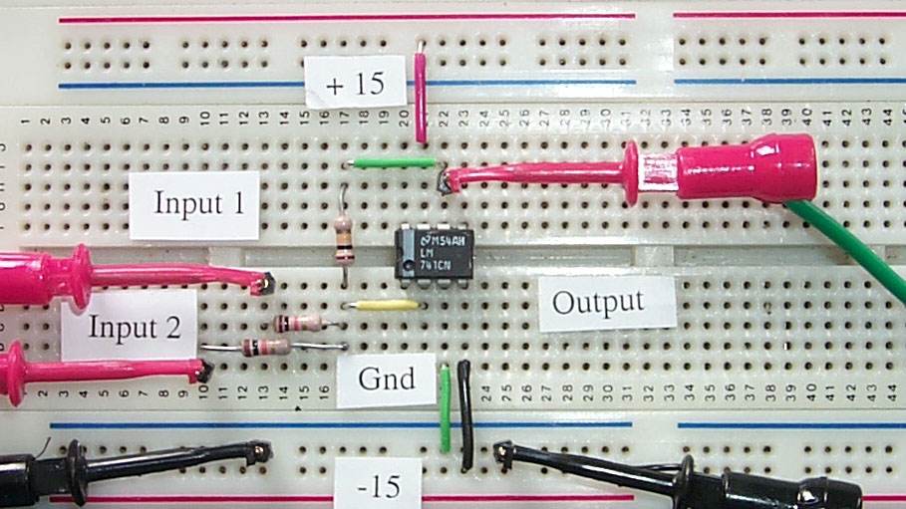

Figure 2-12 Component Layout for an Op-Amp Summing Circuit

For a simple summer, choose R₁ = R₂ = R_{f} = 10 kΩ.
For a summing amplifier with a gain of 10, choose R₁ = R₂ = 10 kΩ and R_{f} = 100 kΩ.
For an averaging circuit, choose R₁ = R₂ = 10 kΩ and R_{f} = 5 kΩ.
Measure the inputs and output with a digital voltmeter or a DAQ card configured as a voltmeter.

Computer Automation 2 : Op-amp Transfer Curve

In assessing the characteristic properties of a device, a graphical representation of the transfer curve provides a unique visualization tool that summarizes all the measurements. Computer automation allows a range of test voltages to be output and the response measured, displayed and analyzed. In this lab, we look at computer generation of test signals and a measurement of the amplifier response displayed in a graphical format.

Launch the LabVIEW program entitled OpAmpTester2.vi from the chapter 2 library. This program uses an analog-output channel on a DAQ card to generate DC test signals and a single analog-input channel to measure the circuit response. The LabVIEW program displays the op-amp response for each input signal and records the transfer curve on a front panel graph. The scan range, scan rate and number of test points can be selected from front panel controls. To save a test set in a spreadsheet format, click on the [Save Data] button.

Note: Without conditioning, the DAQ card reads signals in the bipolar range -5 to +5 volts. If using the DAQ card without conditioning, set the op-amp power supplies to -5 and +5 volts.

If using the summer circuit of eLab Project 2, then set Input 2 of the op-amp circuit to a constant (usually 0 volts), while the other channel Input 1 steps through a range of input signal levels. After wiring the DAQ lines to you test circuit, set the [Start Measurements] button to (On) and enter a range of test voltages. Click on [Run] to observe the op-amp transfer curve. Observe the +/- rails voltage levels and determine the gain of the circuit.

LabVIEW enhancements to the user Interface

- Add a second output channel to the DAQ card so that op-amp summing characteristics can be displayed.
- Create an alarm indicator which lights whenever the output signal level saturates.
- Design a LabVIEW VI to automatically measure the op-amp gain and the rail voltage levels.

A solution can be found on the WEB site "sensor.phys.dal.ca/LabVIEW"

